CIV 102 Course Project Report
TA Raymond Ma
Joaquin Arcilla, Grace Attalla, and Yina Gao
November 30 2021

This report documents how our group approached the matboard bridge design problem with special consideration to the given loading scenarios our bridge will be subject to on testing day. Given a limited amount of matboard to work with and certain dimension constraints informing our decisions, our final design utilizes two unique cross sections across the span of the bridge. Using our analysis of Design Zero, to improve and iterate upon our design, what resulted was a final design predicted to fail at 642 N.

Design Zero — FOS, Predicted Failure Loads, and Plots

According to our calculations, Design Zero fails to support the train load; thus, its FOS under the train loading scenario is 0.851. Furthermore, under point loading, the Design Zero is expected to fail at 193 N due to thin plate buckling of the mid-flange.

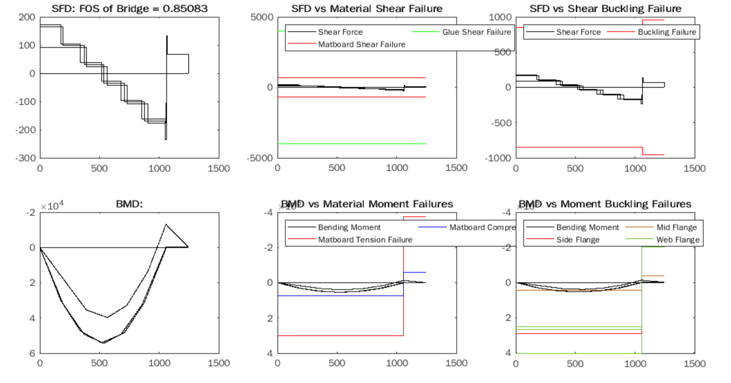
Fig 1 - SFD and BMD for Design Zero during train loading plotted against various modes of failure.
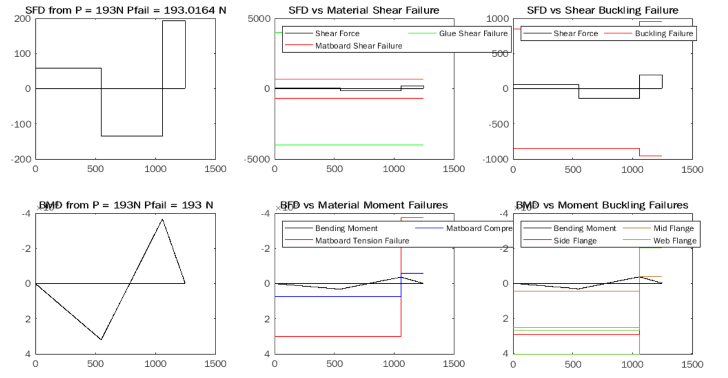
Fig 2 - SFD and BMD for Design Zero during point loading plotted against various modes of failure.

Comparing Design Zero to the Final Design

Design Zero, although simple, was not a design that used the matboard efficiently. In addition, according to our calculations, a bridge with a Design Zero’s uniform cross section would not be able to support the train. The following improvements were implemented into the final design with the goal of creating a bridge .

Improvement | Justification | Reference Equation(s)
Increased height from 75 mm to 121.27 mm | Increases the second moment of area (I) cubically, which increases the geometrical stiffness of the bridge.  This helps increase the flexural stress capacity and decrease shear stress experienced in the bridge, so that the matboard and glue reach compressive/tensile failure slower. | $I = \frac{bh^{3}}{12}$ for rectangles  $I = Σ I_{o.i}+ A_{i}d_{i}^{2}$  $σ = \frac{My}{I}$  $τ = \frac{ VQ}{Ib}$
Incorporating Cross Section A for low shear and bending moment regions | To optimize matboard use, less material is used for portions along the length of the bridge which experience lower shear force and bending moment. The I for these sections are lower. | Refer to equations in the cell above.  Fig 1, SFD and BMD illustrate sections of high and low shear force and bending moment.
Incorporating Cross Section B for high shear and bending moment regions | Cross Section B features more material and area, which increases the I, the geometric stiffness of the bridge. | Refer to the above cell.
Doubling the thickness of the bottom flange in Cross Section B | Doubling the thickness towards the bottom brings the centroidal axis ($\underline{y}$) of the section down, which decreases flexural stress.  More specifically, bringing the centroidal axis towards the bottom of the cross section reduces the portion of the bridge that is under compression for a positive bending moment. | $\underline{y}=\frac{Σ y_{b,i} A_{i}}{Σ{ A}_{i}}$  $σ = \frac{My}{I}$
Increased number of diaphragms and decreased diaphragm spacing | Decreased spacing between diaphragms (a) increases 𝜏_{crit} , meaning the threshold for shear buckling of the webs is raised. | ${τ_{crit}}_{} = \frac{ 5π^{2}E}{{(1 − µ)}^{2}}[({\frac{t}{h})}^{2}+({\frac{t}{a})}^{2}]$
Decreasing width of cross section from 80 mm to 70 mm | Decreases compression width (b), which increases the $σ_{crit}$ that causes thin plate buckling. | $σ_{crit}=\frac{kπ^{2}E}{12(1-μ^{2})}({\frac{t}{b})}^{2}$

Final Design — FOS, Predicted Failure Loads and Plots

The FOS of the final bridge against the train load is 1.88. For the second loading scenario, a point load of 642 N will cause the bridge to fail due to mid-flange thin plate buckling.

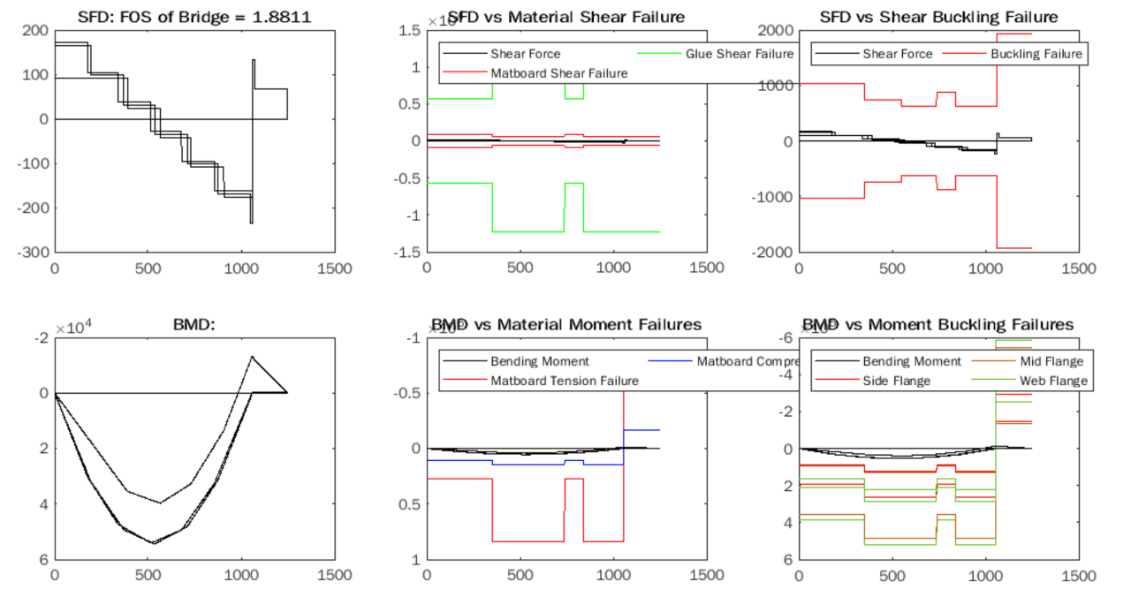
Fig 3 - SFD and BMD for the final design during train loading plotted against various modes of failure.
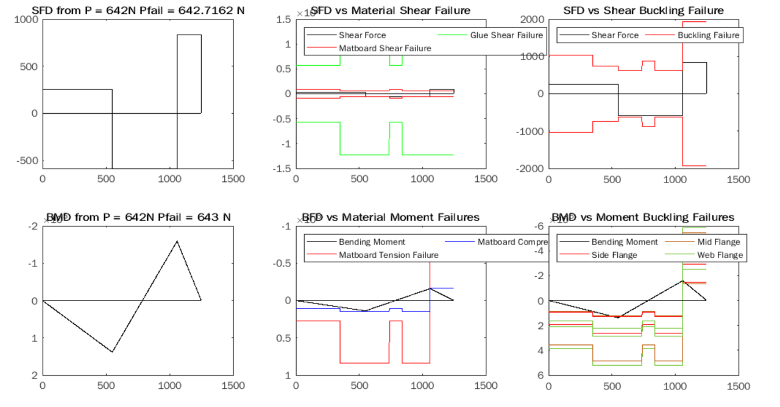
Fig 4 - SFD and BMD for the final design during point loading plotted against various modes of failure.

Construction Process

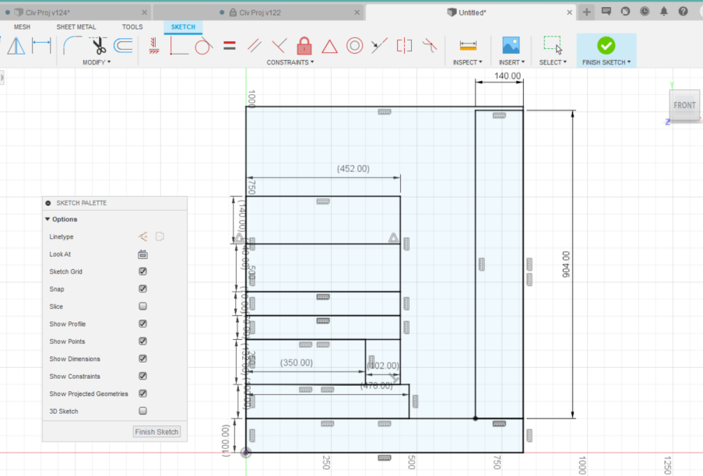  Above: AutoDesk plan for matboard cuts | Planning Matboard Use  AutoDesk was used to plan out the placement of the required pieces on the matboard. The most essential components were accounted for first and arranged such that the least amount of cuts could be made to reduce error. All the free space after was then used to maximize the number of diaphragms that could be created.
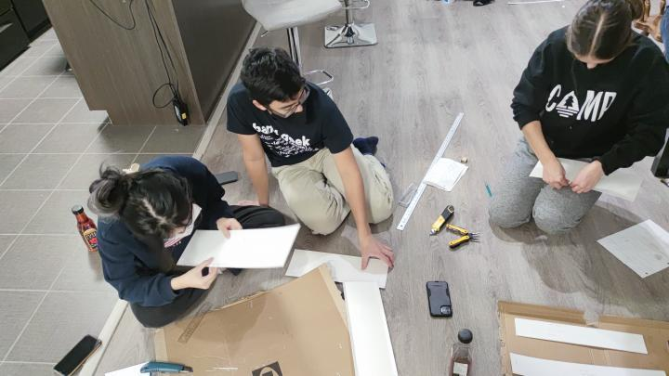  Above: Cutting and folding major members | Cutting and Folding  A box cutter was used to cut each rectangle. For pieces requiring glue tabs, a 10 mm allowance was marked. We then lightly scored along the fold lime and folded the tabs away from the scoring.
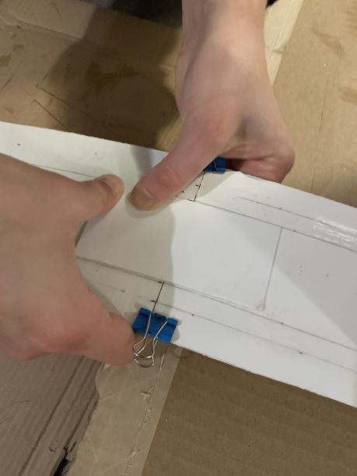  Above: Connecting pieces of the top deck | Making Connections  Since the matboard was shorter than the length of our bridge, our deck, webs, and flanges were cut into multiple rectangles and then attached together. To increase the chances that these members will behave ideally as possible, we reinforced these connections with matboard and contact cement, and clamped the components together while drying to prevent connection failure.
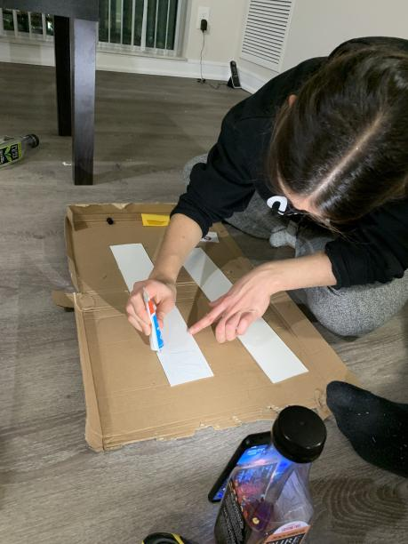  Above: Applying contact cement to the bottom flange    Above: Adhering the webs to the deck  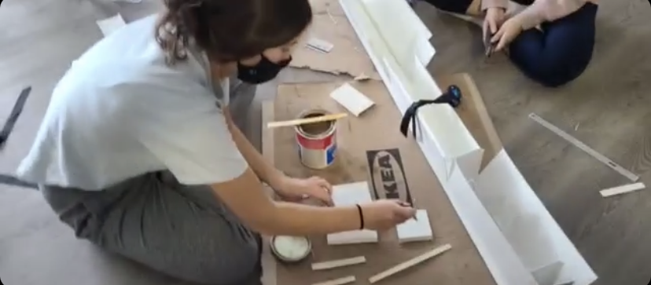  Above: Applying contact cement to diaphragms  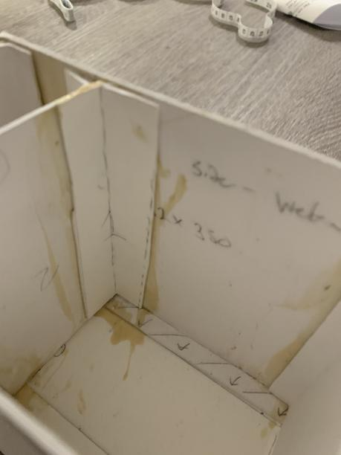  Above: L-shaped tab reinforcements    Above: Bridge drying set-up | Adhering Components with Contact Cement  We applied an even and thin layer of contact cement onto each glue tab using a gift card and waited 15 mins before sticking two two pieces together. While adding on new components to the main bridge structure, we waited at 5-10 minutes for the glue to stick firmly before disturbing the new connections. While the main components were being adhered, someone else in the group would cut and fold diaphragms simultaneously to save time.  First, the deck was assembled, and each pair of webs was adhered to the deck section by section. While drying, the webs were held upright by a ribbon to let the connections dry in position.  After the webs were attached to the deck, we started gluing the diaphragms to one of the webs, section by section. We then started from one end and moved to the opposite end while attaching the diaphragms to the opposing web. While adhering, we pressed the opposing web onto the diaphragm, and applied force from the bottom of the diaphragm to the top, because we noticed the bottom of the diaphragm was the most resistant to creating a solid bond.  After the diaphragms were all adhered, we looked for weaker connections and used leftover matboard to reinforce the connections between the webs and the diaphragms, prioritizing the diaphragms that were placed at the supports and point loads.  Finally, we adhered the bottom flange to the portions of our bridge that featured Cross Section B.  Letting the Bridge Cure  After assembling our bridge, we left our bridge and weighed down the bottom desk using various items and let the contact cement cure fully over in that position for the next 72 hours.

Final Reflection and Predictions

The final predicted failure load under case two is 642N. However, the calculations obtained through the MATLAB script assume a seamless construction process; ideally, during construction, no internal stresses are introduced, allowing the final bridge to carry its full potential load. During our construction process, we observed local fraying of the matboard while folding the glue tabs. In addition, we noticed that the matboard was very resistant to clean folding. While gluing the diaphragm to our webs, the webs resisted their desired placement, and as a result we saw some shearing in the diaphragms. These preexisting stresses observed in the bridge lead us to believe the design will still successfully pass the train loading, but fail before reaching 642N during point loading.

